­­­­­KARNATAK LAW SOCIETY’S

GOGTE INSTITUTE OF TECHNOLOGY

UDYAMBAG, BELAGAVI-590008

(An Autonomous Institution under Visvesvaraya Technological University, Belagavi)

**(APPROVED BY AICTE, NEW DELHI)**



*Course Activity Report on*

***Oil Product Management System***

*Submitted in the partial fulfillment for the academic requirement of*

***5th Semester B.E.***

***in***

***Computer Science Engineering***

***Submitted by***

Aditya Nandeshwar

Aniketh Mahadik

Atreay Kukanur

Fakkiresh Noorshetter

**GUIDE**

*Prof.Ranjana Battur*

**2021 – 2022**

Karnataka Law Society’s

GOGTE INSTITUTE OF TECHNOLOGY

Udyambag Belagavi -590008

Karnataka, India.

**Department of Computer Science and Engineering**



**Certificate**

This is to certify that the Course Activity work titled **“*Oil Product Management System*****”** carried out by Aditya Nandeshwar**,** Aniketh Mahadik, Atreay Kukanur, Fakkiresh Noorshetter bearing **USNs:** 2GI19CS008,2GI19CS019, 2GI19CS028, 2GI19CS041is submittedin partial fulfilment of the requirements for 5th semester B.E. in **Computer Science and Engineering,** Visvesvaraya Technological University, Belagavi. It is certified that all corrections/ suggestions indicated have been incorporated in the report. The course project report has been approved as it satisfies the academic requirements prescribed for the said degree.

Date: Signature of Guide

Place: Belagavi

Guide Name

***Prof.Ranjana Battur***

KLS Gogte Institute Technology, Belagavi

Name of the Examiners Signature of the Examiners

1.___________________ 1.____________________

2.____________________ 2.____________________

**Title: *Oil Product Management System***

**Team Members Details:**

|  |  |  |
| --- | --- | --- |
| **S. No.** | **USN** | **Student Name** |
| 1 | 2GI19CS008 | Aditya Nandeshwar |
| 2 | 2GI19CS019 | Aniketh Mahadik |
| 3 | 2GI19CS028 | Atreay Kukanur |
| 4 | 2GI19CS041 | Fakkiresh Noorshetter |

**Marks Allocation:**

|  |  |  |  |  |  |  |
| --- | --- | --- | --- | --- | --- | --- |
|  | **Batch No.:** | | | | | |
| 1. | Seminar Title: | Marks Range | **USN** | | | |
| **2GI19CS008** | **2GI9CS019** | **2GI19CS028** | **2GI19CS041** |
| 2. | Abstract (PO2) | 0-2 |  |  |  |  |
| 3. | Application of the topic to the course (PO2) | 0-3 |  |  |  |  |
| 4. | Literature survey and its findings (PO2) | 0-4 |  |  |  |  |
| 5. | Methodology, Results and Conclusion  (PO1, PO3, PO4) | 0-6 |  |  |  |  |
| 6. | Report and Oral presentation skill (PO9, PO10) | 0-5 |  |  |  |  |
|  | Total | 20 |  |  |  |  |

**Signature of Staff:**

Dear Students,

First of all, we thank you for your visit to our industry and presenting a website demo designed by you all.

You have impresses us with your website designs. We are pleased to inform that our competed authority has decided to give an opportunity to you for designing a website for our company.

We request you to include following specification while designing our website:

1. Provide an attractive interface for the Oil products management website.
2. Provide some details and images related to the Oil products.
3. Provide the features like billing and ordering oil products chosen by the customers.
4. Provide our contact details so that the customers can query about anything directly to the oil seller.

Warm regard,

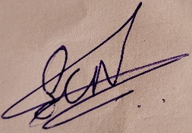

Santosh C Noorshettar

Shri Fakeera Channaveereshwar Oil Industries, Shirahatti-582120 Karnataka.

**CONTENTS**

1. PROBLEM STATEMENT
2. PROPOSED SYSTEM
3. OBJECTIVE
4. HARDWARE AND SOFTWARE REQUIREMENTS
5. FUNCTIONALAND NON-FUNCTIONAL REQUIREMENTS
6. MODULE
7. ER DIAGRAM
8. USE CASE DIAGRAM

* USE CASE DESCRIPTION

9. SEQUENCE DIAGRAMS

10. ACTIVITY DIAGRAMS

11. UI MODEL

**Problem Statement**

The traditional oil product management system has various flaws in it as because of which most of the people don’t use the system even though it has several advantages over traditional stores. The biggest problem is that it takes at least a day to deliver a product to the customer. While some other issues are a duplication of the product means the product is shown on the GUI some time differs with the original product due to which next time that customer go to buy the product through the traditional type of store.

***Proposed system:***

The oil product management system has many advantages, compare to traditional store as one can compare the cost of a product with other oil selling shops, and if a user dislikes any product he/she can return it. While we can make use of the current technology to overcome the problem with the existing system. The oil companies can use a flying robot, so when a user places an order, the company will send the product through the robot. The robot will find the user by using the GPS, and in this way, we can reduce the time to deliver a product. While before sending a product the oil company will check the product that it is same or not with the requested order.

***Objective:***

The oil product management system will primarily provide a platform to purchase, sell, distribution of items, product or service on some network. It will provide an option to a customer for the comparison of product with another seller, while a shop is available only at day time the e-commerce is available 24 hours of a day and seven days of the week. The oil management system will be a huge marketplace as most of the business are going to implement based on the internet. This system will provide the detailed description of the products to users so that they can compare to the different product and will by the one which is more suitable to them.

***Software Requirements:***

|  |  |
| --- | --- |
| ***Name of Components*** | ***Specification*** |
| Operating System | Windows XP, Windows 8, 10 and newer versions. |
| Language | Python |
| Database | DB Browser, Oracle SQL |
| Software Development Kit | Python, SQL |

***Hardware Requirements:***

|  |  |
| --- | --- |
| ***Name of Component*** | ***Specification*** |
| Processor | Platinum III 630MHz |
| RAM | 128MB |
| Hard Disk | 20GB |
| Moniter | 15” Color Moniter |

***WEBPAGE FRONTEND AND BACKEND DEVELOPED USING :*** *Visual Studio Code*

***DATABASE SOFTWARE :*** *MySQL*

**Module:**

***Registration:***

In order to use the system the users will need to register in the system, and for registration, they need to provide various information related to them such as name, address, etc.

**Search bar:**

This provides users with an option through which they can search the product they want to purchase.

**Cart:**

After selecting a product if the user wants to purchase it, later they can save the product in the cart.

**Check out:**

Through this module, the user can place their order and can choose preferred method for payment.

**Purchase history:**

This will show the purchase done by the user in the past.

**REQUIREMENTS ANALYSIS:**

***FUNCTIONAL REQUIREMENTS :***

***User:***

• User can create account

• User can log in into the Website

* Search for Products
* Add to Cart
* Make Payment

***Admin:***

•Admin can login into website

• Admin can manage products

• Admin keep the data of all payment

***NON-FUNCTIONAL REQUIREMENTS:***

* *Usability*

1. The system must be easy to use by both managers and users such that they do not need to read an extensive amount of manuals.
2. The system must be quickly accessible by both managers and users.
3. The system must be intuitive and simple in the way it displays all relevant data and relationships.
4. The menus of the system must be easily navigable by the users with buttons that are easy to understand.

* *Reliability*

1. The System must give accurate inventory status to the user continuously. Any inaccuracies are taken care by the regular confirming of the actual levels with the levels displayed in the system.
2. The System must successfully add any type of packets given by the user and provide estimations and sales status in relevance with the newly updated entities.
3. The system must provide a password enabled login to the user to avoid any foreign entity changing the data in the system.
4. The system should provide the user updates on completion of requested processes and if the requested processes fail, it should provide the user the reason for the failure.
5. The system should not update the data in any database for any failed processes.

* *Supportability*

1. The software is designed such that it works even on systems having the minimum configuration.
2. The system is adaptable even if additional plugins or modules are added at a later point.
3. The data can be exported to the manager so as to make the system more portable.

* *Packaging*

1. The system must be able to run on the Windows operating systems beginning with Windows XP, and must be able to run on future releases such as the upcoming Windows 8
2. The software must incorporate a license key authentication process.
3. The packaging must come with a manual that details the use of the system, and also the instructions on how to use the program. This manual may be included either in a booklet that comes with the software, or on the disc that the software itself is on.

**ER-Diagram:**

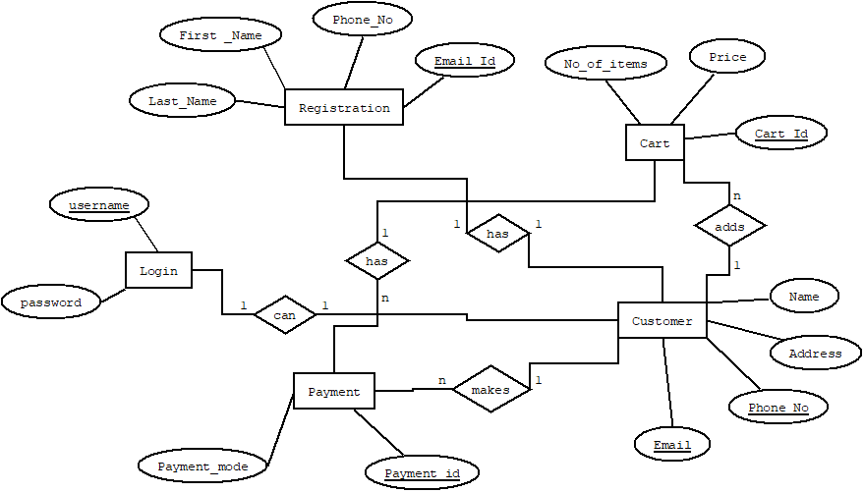

**Class Diagram :**

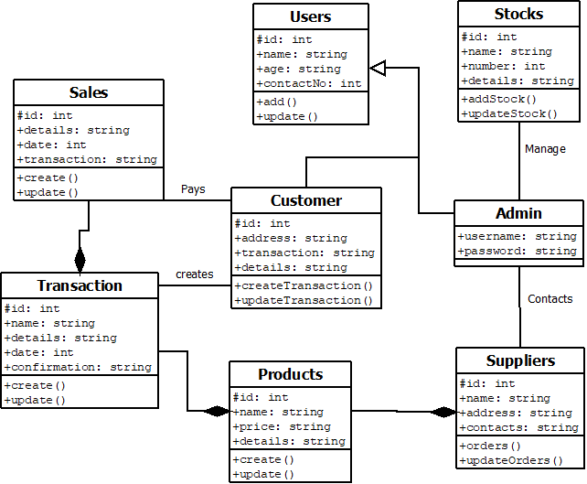

**Use Case Diagram :**

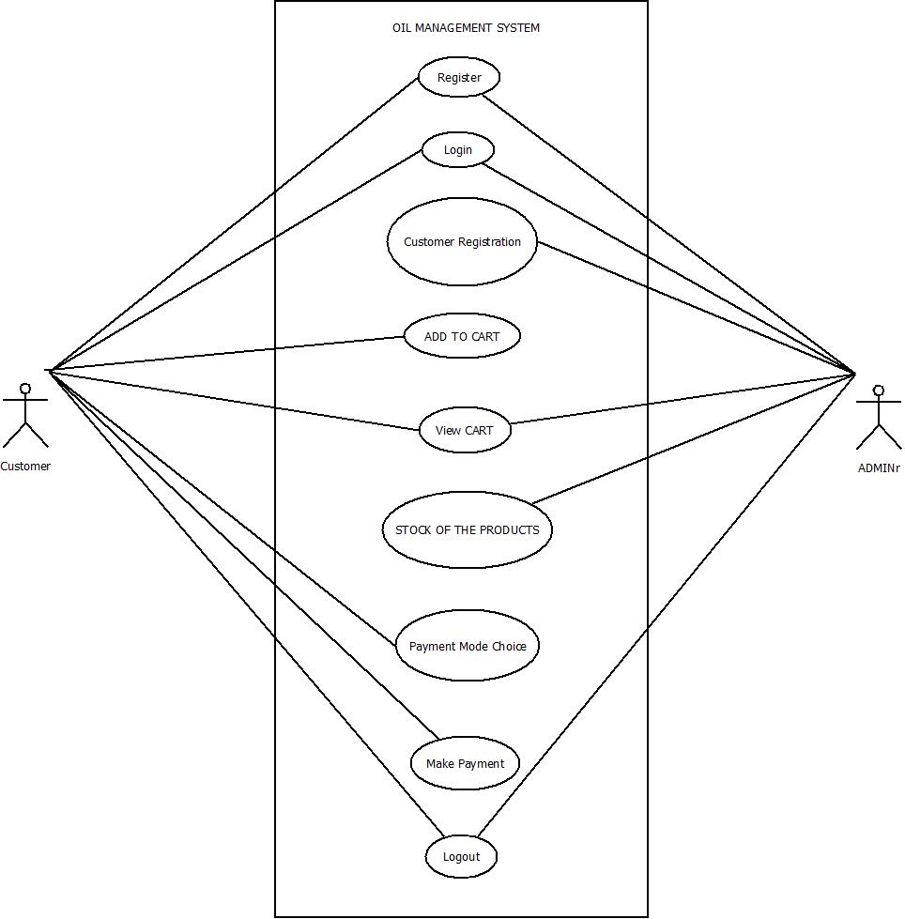

**REGISTRATION**

|  |  |
| --- | --- |
| Use Case Name: | Registration |
| Scenario: | User registration to the system. |
| Brief Description | User should register their own username and password. |
| Actor: | User (customer) |
| Pre-Condition: | Must be valid username and registration type. |
| Post-Condition: | User must confirm registration with activation key. |
| Flow of events: | |  |  | | --- | --- | | User (customer) | System | | • Must provide valid username.  • Must fill up all required field. | • Confirm valid username.  • Confirm unique username. | |
| Exception Condition: | Cannot get permission to create an account. |

**LOGIN**

|  |  |
| --- | --- |
| Use Case Name: | Login |
| Scenario: | User (customer) and Admin Login to the system. |
| Brief Description | Customer and Admin should login with valid username and password. |
| Actor: | User (Customer) and Admin. |
| Pre-Condition: | Must be valid username and password. |
| Post-Condition: | After successfully login to the system, every user can access their accessible data. |
| Flow of events: | |  |  | | --- | --- | | User (Customer), Admin | System | | • Must provide Valid username and Password | • Confirm valid username.  • Confirm unique username.  • Give access to the system | |
| Exception Condition: | Give permission to access the account. |

**ADD TO CART**

|  |  |
| --- | --- |
| Use Case Name: | Add to cart |
| Scenario: | User (customer) adds product to the cart.. |
| Brief Description | User can view and add desired item into cart. |
| Actor: | User (customer) |
| Pre-Condition: | Stock should be available. |
| Post-Condition: | User can verify the products in the cart. |
| Flow of events: | |  |  | | --- | --- | | User (customer) | System | | • User can manipulate the products present in the cart. | • Confirms the products added in the cart. | |
| Exception Condition: | Product which is intended to be added to cart doesn’t already exist in the cart. |

**MAKE PAYMENT**

|  |  |
| --- | --- |
| Use Case Name: | Make Payment |
| Scenario: | User (customer, admin) can manage the payment. |
| Brief Description | User can make payment. |
| Actor: | User (customer, admin) |
| Pre-Condition: | Add to cart. |
| Post-Condition: | Transaction id generation. |
| Flow of events: | |  |  | | --- | --- | | User (customer) | System | | • Select a payment method | • Confirm Payment and generate transaction Id. | |
| Exception Condition: | User can update products after transaction Id generation. |

**SEQUENCE DIAGRAM**

**LOGIN(BASIC FLOW):**

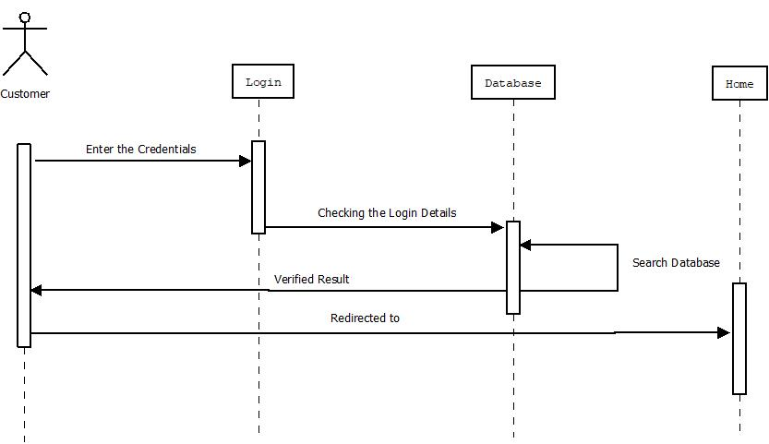

**REGISTRATION :**

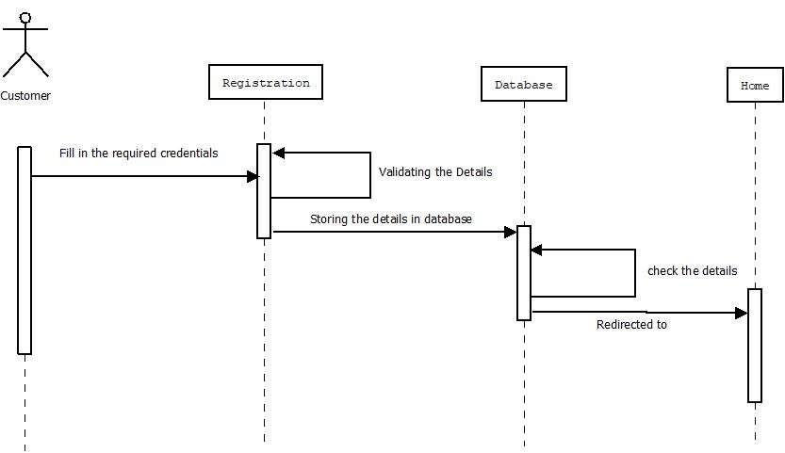

**ADD TO CART :**

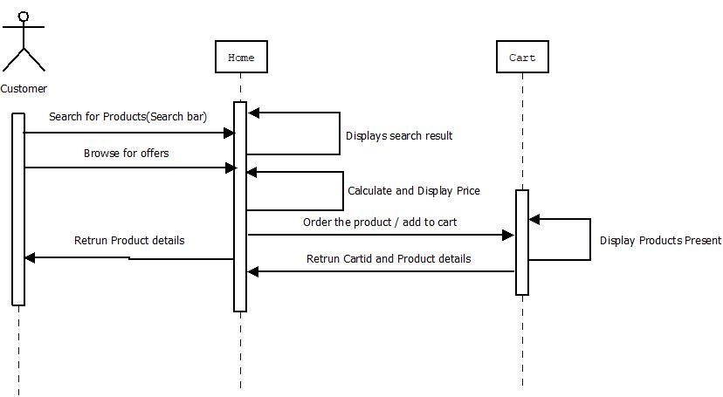

**MAKE PAYMENT :**

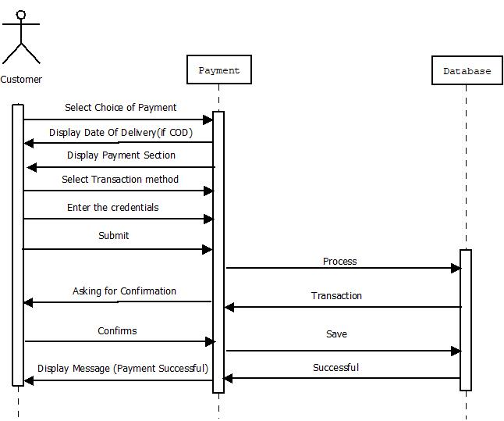

**ACTIVITY DIAGRAM**

**LOGIN :**

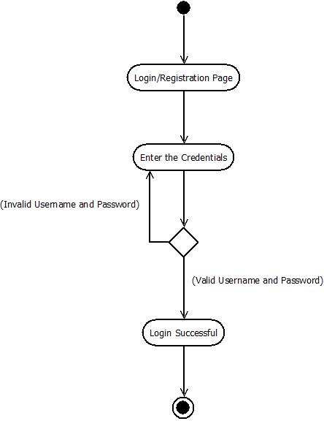

**REGISTRATION:**

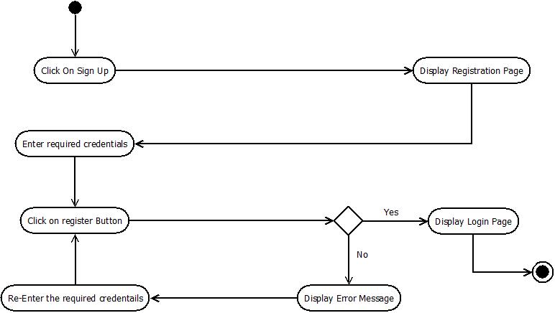

**ADD TO CART :**

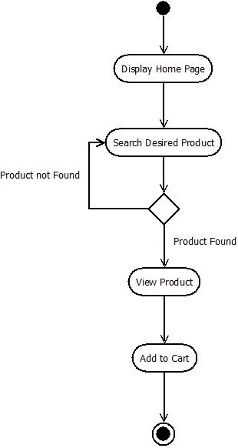

**MAKE PAYMENT :**

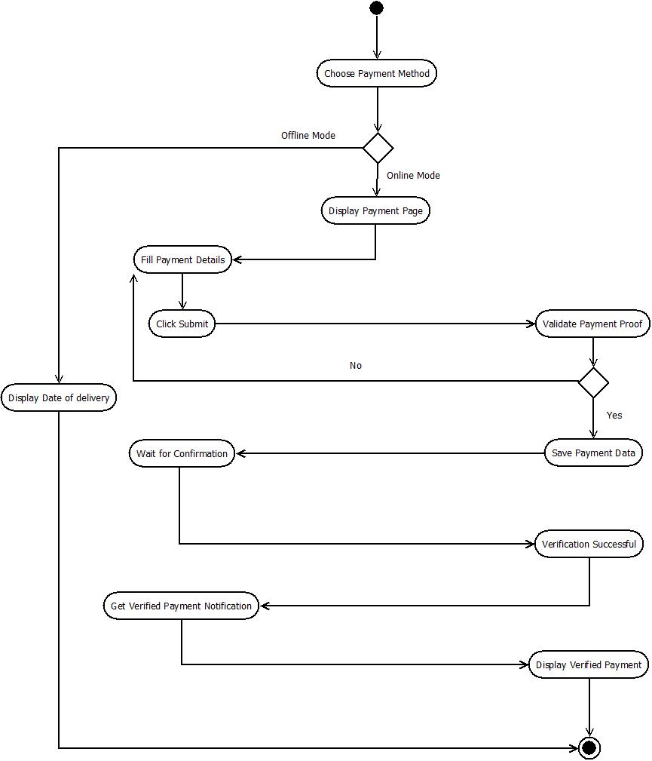

**UI MODEL**

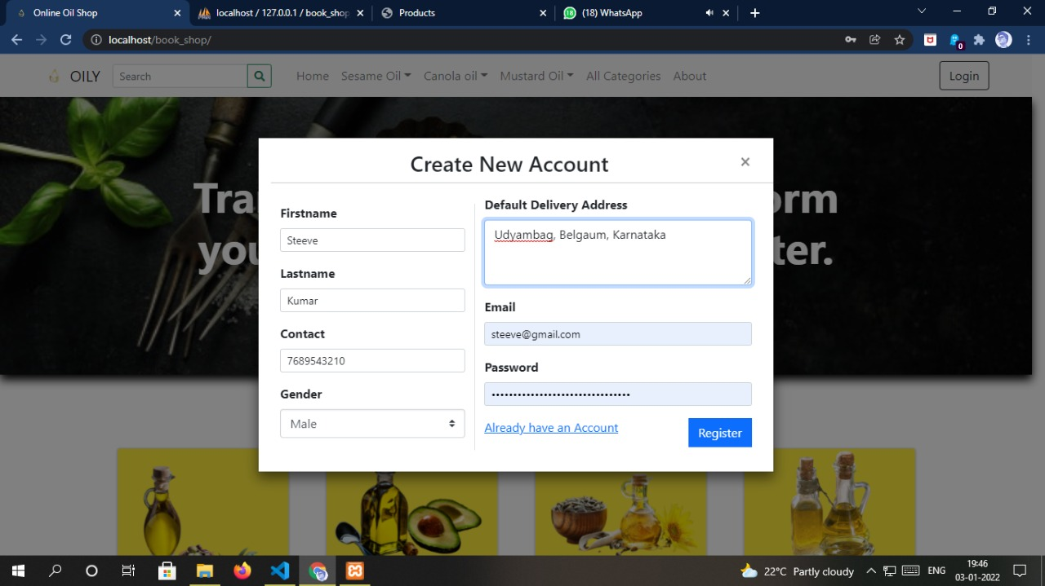

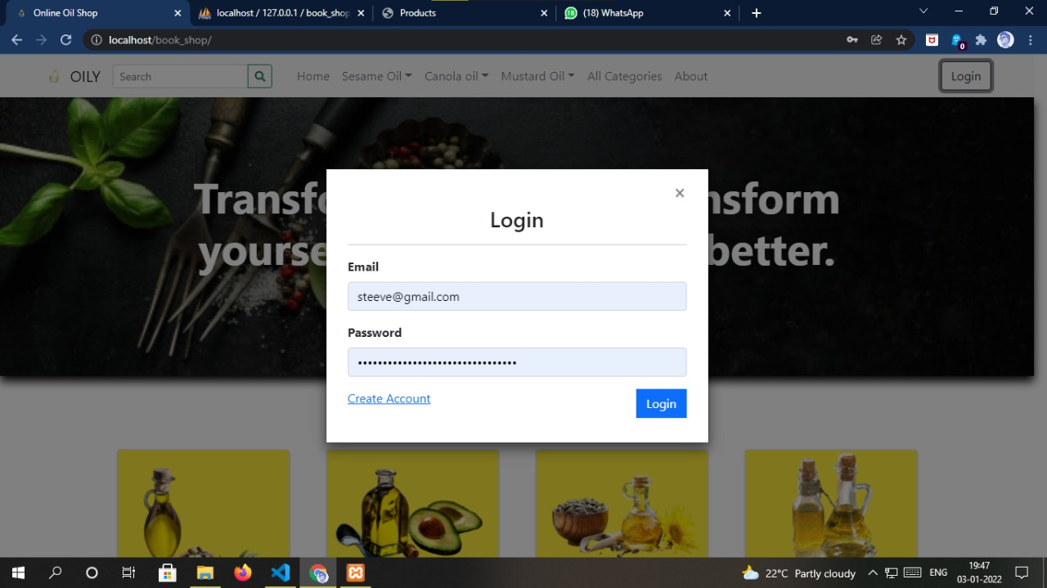

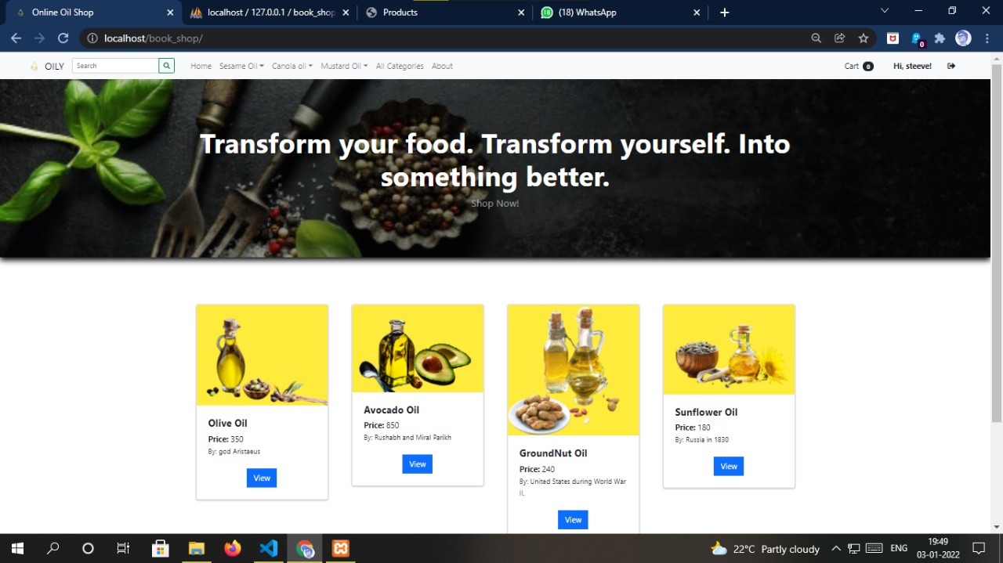

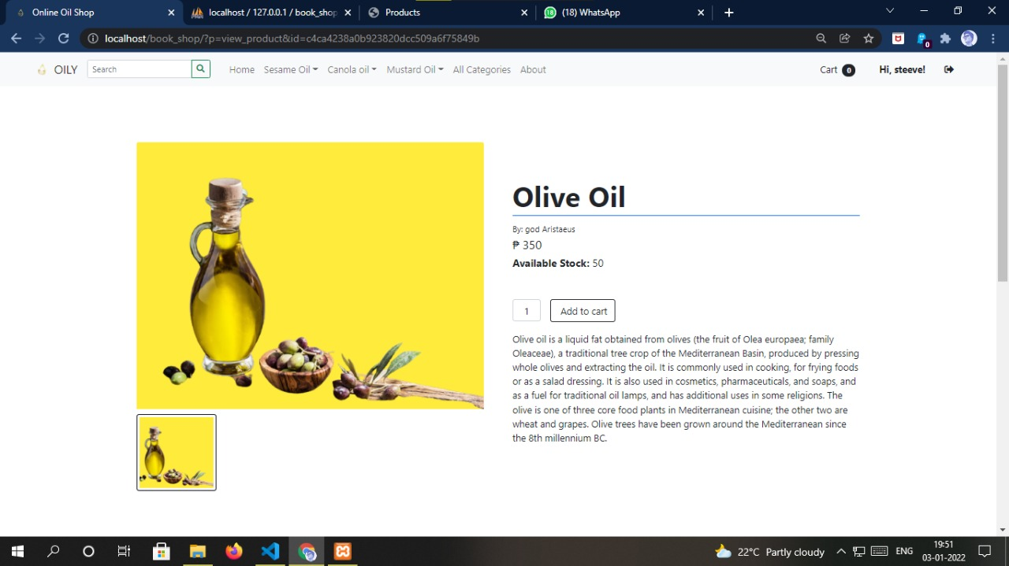

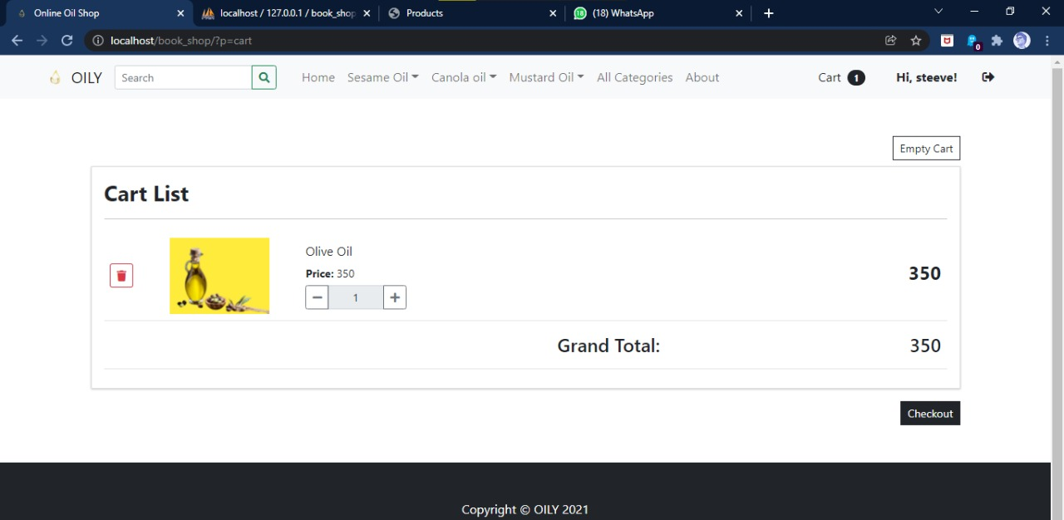

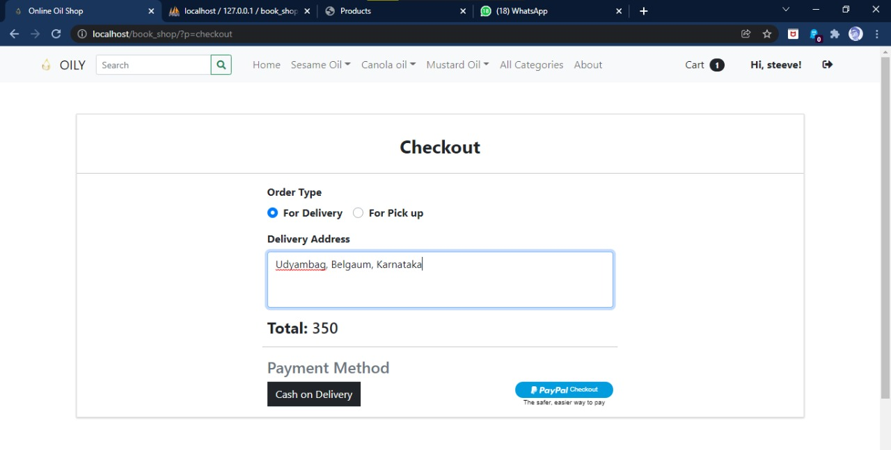

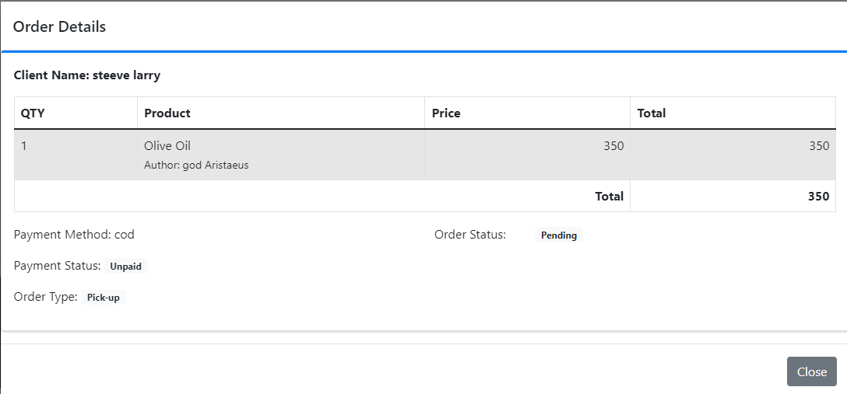

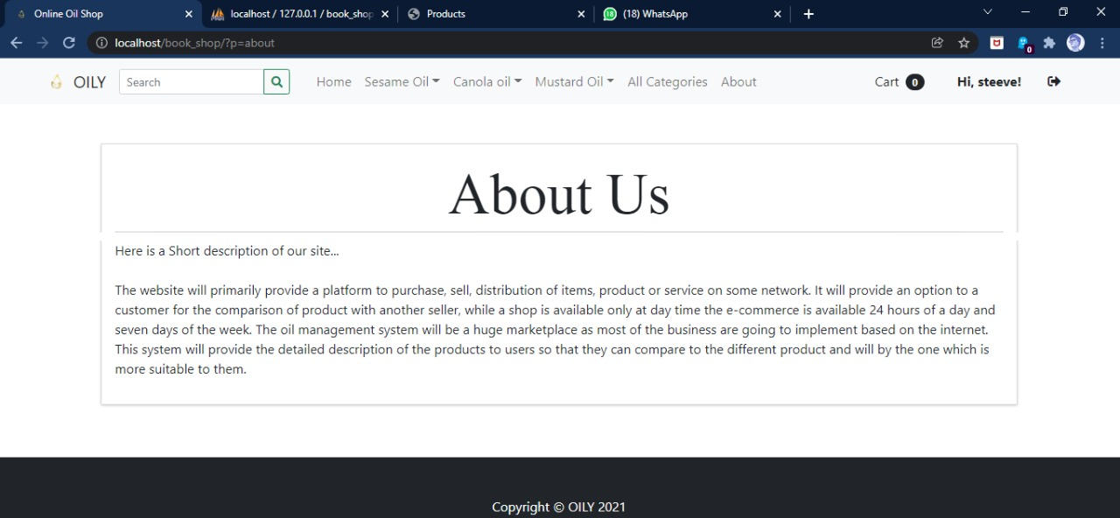

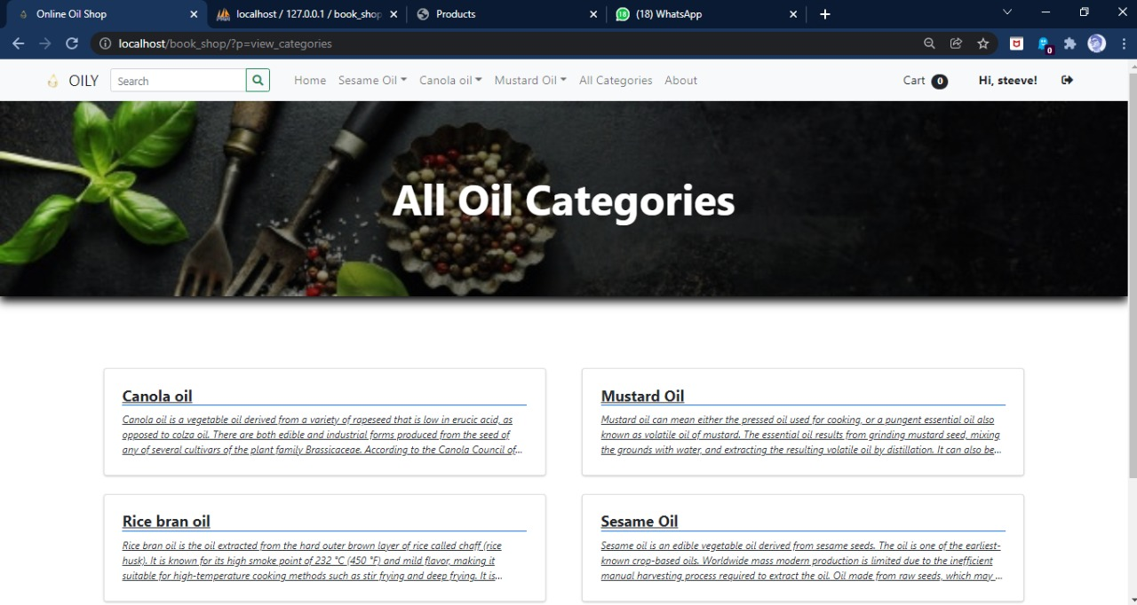

**Conclusion :**

Innovation and Sustainable Economic Competitive Advantage: From Regional Development to Global Growth

1831

4.0 CONCLUSION

Oil and gas (O&G) industry plays a very important part as the nation building, despite the fact that

each of its facility is having a unique requirement. As millions of money are needed to jump start

an O&G project, appropriate initiatives are apparently essential in ensuring the success of a

particular project. Effective project management approach is seemed as one of the best solutions to

this dilemma. It can be seen that the relevancy of having a structured project management approach

and guidance such as Project Management Book of Knowledge (PMBOK) and Stage Gate Project

Management Process (SGPMP) shall be the way forward for future project implementation. The

implementation can be also tailored made according to each local country requirement and business, where

the upstream and downstream O&G projects might have some differences in terms of approval authority

and project stages. Hence, as this paper has successfully achieved its aim of reviewing the project

management of O&G industry, further study is expected to be carried out in investigating the

specific critical success factors that ensure the success delivery of O&G project worldwide.

Innovation and Sustainable Economic Competitive Advantage: From Regional Development to Global Growth

1831

4.0 CONCLUSION

Oil and gas (O&G) industry plays a very important part as the nation building, despite the fact that

each of its facility is having a unique requirement. As millions of money are needed to jump start

an O&G project, appropriate initiatives are apparently essential in ensuring the success of a

particular project. Effective project management approach is seemed as one of the best solutions to

this dilemma. It can be seen that the relevancy of having a structured project management approach

and guidance such as Project Management Book of Knowledge (PMBOK) and Stage Gate Project

Management Process (SGPMP) shall be the way forward for future project implementation. The

implementation can be also tailored made according to each local country requirement and business, where

the upstream and downstream O&G projects might have some differences in terms of approval authority

and project stages. Hence, as this paper has successfully achieved its aim of reviewing the project

management of O&G industry, further study is expected to be carried out in investigating the

specific critical success factors that ensure the success delivery of O&G project worldwide.

Oil and gas (O&G) industry plays a very important part as the nation building, despite the fact that

each of its facility is having a unique requirement. As millions of money are needed to jump start

an O&G project, appropriate initiatives are apparently essential in ensuring the success of a

particular project. Effective project management approach is seemed as one of the best solutions to

this dilemma. It can be seen that the relevancy of having a structured project management approach

and guidance such as Project Management Book of Knowledge (PMBOK) and Stage Gate Project

Management Process (SGPMP) shall be the way forward for future project implementation. The

implementation can be also tailored made according to each local country requirement and business, where

the upstream and downstream O&G projects might have some differences in terms of approval authority

and project stages. Hence, as this paper has successfully achieved its aim of reviewing the project

management of O&G industry, further study is expected to be carried out in investigating the

specific critical success factors that ensure the success delivery of O&G project worldwide

Oil and gas (O&G) industry plays a very important part as the nation building, despite the fact that

each of its facility is having a unique requirement. As millions of money are needed to jump start

an O&G project, appropriate initiatives are apparently essential in ensuring the success of a

particular project. Effective project management approach is seemed as one of the best solutions to

this dilemma. It can be seen that the relevancy of having a structured project management approach

and guidance such as Project Management Book of Knowledge (PMBOK) and Stage Gate Project

Management Process (SGPMP) shall be the way forward for future project implementation. The

implementation can be also tailored made according to each local country requirement and business, where

the upstream and downstream O&G projects might have some differences in terms of approval authority

and project stages. Hence, as this paper has successfully achieved its aim of reviewing the project

management of O&G industry, further study is expected to be carried out in investigating the

specific critical success factors that ensure the success delivery of O&G project worldwide

Oil and gas (O&G) industry plays a very important part as the nation building, despite the fact that

each of its facility is having a unique requirement. As millions of money are needed to jump start

an O&G project, appropriate initiatives are apparently essential in ensuring the success of a

particular project. Effective project management approach is seemed as one of the best solutions to

this dilemma. It can be seen that the relevancy of having a structured project management approach

and guidance such as Project Management Book of Knowledge (PMBOK) and Stage Gate Project

Management Process (SGPMP) shall be the way forward for future project implementation. The

implementation can be also tailored made according to each local country requirement and business, where

the upstream and downstream O&G projects might have some differences in terms of approval authority

and project stages. Hence, as this paper has successfully achieved its aim of reviewing the project

management of O&G industry, further study is expected to be carried out in investigating the

specific critical success factors that ensure the success delivery of O&G project worldwide

Oil and gas (O&G) industry plays a very important part as the nation building, despite the fact that

each of its facility is having a unique requirement. As millions of money are needed to jump start

an O&G project, appropriate initiatives are apparently essential in ensuring the success of a

particular project. Effective project management approach is seemed as one of the best solutions to

this dilemma. It can be seen that the relevancy of having a structured project management approach

and guidance such as Project Management Book of Knowledge (PMBOK) and Stage Gate Project

Management Process (SGPMP) shall be the way forward for future project implementation. The

implementation can be also tailored made according to each local country requirement and business, where

the upstream and downstream O&G projects might have some differences in terms of approval authority

and project stages. Hence, as this paper has successfully achieved its aim of reviewing the project

management of O&G industry, further study is expected to be carried out in investigating the

specific critical success factors that ensure the success delivery of O&G project worldwide

Oil and gas (O&G) industry plays a very important part as the nation building, despite the fact that

each of its facility is having a unique requirement. As millions of money are needed to jump start

an O&G project, appropriate initiatives are apparently essential in ensuring the success of a

particular project. Effective project management approach is seemed as one of the best solutions to

this dilemma. It can be seen that the relevancy of having a structured project management approach

and guidance such as Project Management Book of Knowledge (PMBOK) and Stage Gate Project

Management Process (SGPMP) shall be the way forward for future project implementation. The

implementation can be also tailored made according to each local country requirement and business, where

the upstream and downstream O&G projects might have some differences in terms of approval authority

and project stages. Hence, as this paper has successfully achieved its aim of reviewing the project

management of O&G industry, further study is expected to be carried out in investigating the

specific critical success factors that ensure the success delivery of O&G project worldwide

Oil industry plays a very important part as the nation building, despite the fact that each of its facility is having a unique requirement. As millions of money are needed to jump start an Oil project, appropriate initiatives are apparently essential in ensuring the success of a particular project. Effective project management approach is seemed as one of the best solutions to this dilemma. It can be seen that the relevancy of having a structured project management approach and guidance such as Project Management Book of Knowledge (PMBOK) and Stage Gate Project Management Process (SGPMP) shall be the way forward for future project implementation. The implementation can be also tailored made according to each local country requirement and business, where the upstream and downstream Oil projects might have some differences in terms of approval authority and project stages. Hence, as this paper has successfully achieved its aim of reviewing the project management of O&G industry, further study is expected to be carried out in investigating the specific critical success factors that ensure the success delivery of Oil project worldwide.

**References :**

1)A. Prates, F.E.A. Freigedo and P.O. Almeida, A Critical Assessment of the Main Challenges Related to Feasibility Studies, Risk Analysis and Monitoring of Current Offshore Projects in Brazil, Offshore Technology Conference, OTC 24421, Rio De Janeiro, Brazil, 29-31 Oct 2013.

2)A.R.S. Harris and A.R. Abd. Rahman, Turbomachinery in Oil and Gas Facilities Project: Execution and Main Challenges, IEM Bulletin: Engineers, The Institutions of Engineers Malaysia, April 2014 (4) 21-24.

3)A.R.S. Harris, A.R. Abd. Rahman and A.M. Haris, Concept of Turbomachinery Selection for Upstream Oil and Gas Facilities Project, Proceedings of 2nd International Conference on Mechanical, Automotive and Aerospace Engineering, Kuala Lumpur Malaysia, 2-4 July 2013.

4)B. Asrilhant, A Program for Excellence in the Management of Exploration and Production Projects, Proceedings of Offshore Technology Conference, OTC 17421, Houston Texas USA, 2-5 May 2005.

5) C.S. Alvarado, and J.V. Wagner, Next Generation FPSO: Combining Production and Gas Utilization, Proceedings of Offshore Technology Conference, OTC 14002, 2002.